Course Assignment. QUB Open Learning

John Donne. Maureen Boyle Autumn 2023
Anita Greg (Anita Newsam)
anitagreg@gmail.com 07944969373

I have chosen two poems that are both to do with being stuck, one physically and one mentally

1/ The Calm
Biographical context

The biographical context is that Donne, a cradle Catholic, having studied at Oxford University and possibly Cambridge as well found himself unemployed and with talent but no obvious prospects so, with a number of other Ex students, he enlisted with the Earl of Essex to attack the Spanish fleet in the harbour of Cadiz. Having survived that expedition and still with no other job prospects, he took ship with the Earl and Raleigh again to attack the Spanish treasure ships in the Azores. After nearly being wrecked in a terrible storm and reaching the Azores they were becalmed.

As a side circumstance, there occurred here in the Azores a falling-out between Essex and Raleigh which arguably resulted In both their deaths and, down the line, that of King Charles the First but of course none of them were to know that and it has nothing to do with the poem which Donne wrote as a letter to his college friend, Christopher Brooke.

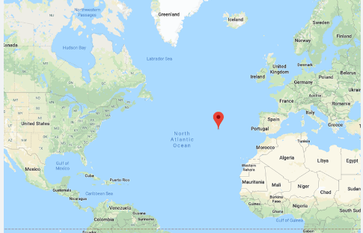

- Our storm is past, and that storm's tyrannous rage,  - A stupid calm, but nothing it, doth 'suage.  - The fable is inverted, and far more  - A block afflicts, now, than a stork before.  - Storms chafe, and soon wear out themselves, or us;  - In calms, Heaven laughs to see us languish thus.  - As steady'as I can wish that my thoughts were,  - Smooth as thy mistress' glass, or what shines there,  - The sea is now; and, as the isles which we  - Seek, when we can move, our ships rooted be.  - As water did in storms, now pitch runs out;  - As lead, when a fir'd church becomes one spout.  - And all our beauty, and our trim, decays,  - Like courts removing, or like ended plays.  - The fighting-place now seamen's rags supply;  - And all the tackling is a frippery.  - No use of lanthorns; and in one place lay  - Feathers and dust, to-day and yesterday.  - Earth's hollownesses, which the world's lungs are,  - Have no more wind than the upper vault of air.  - We can nor lost friends nor sought foes recover,  - But meteor-like, save that we move not, hover.  - Only the calenture together draws  - Dear friends, which meet dead in great fishes' jaws;  - And on the hatches, as on altars, lies  - Each one, his own priest, and own sacrifice.  - Who live, that miracle do multiply,  - Where walkers in hot ovens do not die.  - If in despite of these we swim, that hath  - No more refreshing than our brimstone bath;  - But from the sea into the ship we turn,  - Like parboil'd wretches, on the coals to burn.  - Like Bajazet encag'd, the shepherds' scoff,  - Or like slack-sinew'd Samson, his hair off,  - Languish our ships. Now as a myriad  - Of ants durst th' emperor's lov'd snake invade,  - The crawling gallies, sea-gaols, finny chips,  - Might brave our pinnaces, now bed-rid ships.  - Whether a rotten state, and hope of gain,  - Or to disuse me from the queasy pain  - Of being belov'd and loving, or the thirst  - Of honour, or fair death, out-push'd me first,  - I lose my end; for here, as well as I,  - A desperate may live, and a coward die.  - Stag, dog, and all which from or towards flies,  - Is paid with life or prey, or doing dies.  - Fate grudges us all, and doth subtly lay  - A scourge, 'gainst which we all forget to pray.  - He that at sea prays for more wind, as well  - Under the poles may beg cold, heat in hell.  - What are we then? How little more, alas,  - Is man now, than before he was? He was  - Nothing; for us, we are for nothing fit;  - Chance, or ourselves, still disproportion it.  - We have no power, no will, no sense; I lie,  - I should not then thus feel this misery. | 1/ ‘Our’ rather than ‘The’ starts this poem with an open mouth as the classic ‘O’ that starts an Epic  … then narrowing and focussing into the closed-lips ‘M’ of storm and the poem gets going but do things get better after the storm? They do not.  2/ He uses “stupid” as an adjective derived from “stupor”  3/ He is referring here to Aesop's fable of “The Frogs Desiring a King” when the aimless frogs ask Jove for a king and he gives them a huge log. The frogs are initially thrilled by having this log as a king but soon get cheeky and start crawling all over it.  They ask Jove to send them a better king that they can Really respect and Jove sends them a stork that swallows the lot of them.  Donne is saying that the moral is inverted here because at least a storm is, by its very nature, temporary whereas the horror of the inert log may have be endless  That“Heaven laughs”implies his mind is still in Aesop’s pagan world as I don’t think any variety of Christianity has Heaven laughing at people’s misfortunes  or even poor choices.  7/This reminds me of the story of Ulysses wanting to continue his journey westwards as told by Tennyson or the old Irish and Welsh Immrama of journeys to the Otherworld. Did he know of these Welsh voyages? Possibly if he knew Dee who based Britain’s claim to the New World on the discovery by Prince Madoc of a great land across the Atlantic  The smoothness which should be a good and a glamorous quality, here just means they cannot move. Dreamlike and nightmarish, it is only his thoughts which are turbulent. They are as rooted as the islands they are seeking and are somehow outside the natural.world  11/ and the pitch that protects them from the water melts and the solid becomes another liquid and runs into the sea  12/ I have read that this is taken as a critique of Catholicism or the State of England or somesuch. This seems unlikely to me as Donne was at the sack of Cadiz and if he saw lead melting on church roofs then it was probably something he was a part of causing. I take it as colourful description of the melting tar  13/ The boats are falling apart and all their finery is in tatters. This reminds me of Macbeth’s “All our yesterdays” speech at the end of the play, written in 1606  14/ Like courts packing up and leaving … ironic because the ships are not going anywhere  17/ Lanthorns are the big lanterns used for a lighthouse or a belfry and perhaps be used for signalling.  If there was no news and nobody was moving anyway then there would be no need for signals.  I cannot imagine a more perfect image of total stasis than ‘in one place lay  Feathers and dust, to-day and yesterday’  Ben Johnson apparently knew this passage by heart and would recite it often  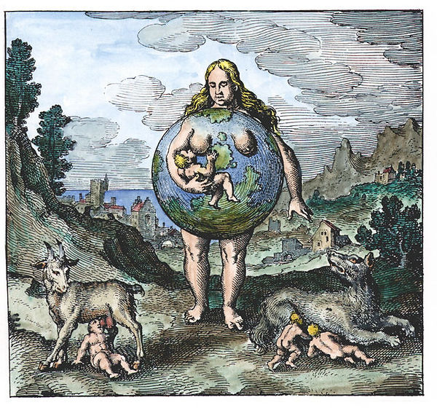  19/ Wind is caused by the movement of air from an area of High Pressure to an area of Low Pressure (a depression). Wind is also the breath of the world. If the World has lungs then this is seeing the World as living entity as in this picture from Atalanta Fugiens (Atalanta Fleeing), a book published in 1617 by Michael Maier - and well preceding James Lovelock’s vision of Gaia.  There IS wind in the stratosphere but even the most scientificaly minded Elizabethans couldn’t have known that  21/ This is like the dream state of not being able to move towards friend or away from enemies but hovering, remaining in one place in the air  23/ Only the calenture (a sea fever) reunites them .. are they a having a fever dream or are they really dead and in the water being eaten by sharks? Either or both.  Friends meet again only in the jaws of fish.  It is easy to see why the French Symbolists were instrumental in the 20th century revival of Donne’s writing as there is a direct line from this to the surreal maritime dreamscape of Rimbaud’s ‘Le Bateau Ivre’  and talking of influences, and as far as I know, Coleridge who wrote plenty and often disparagingly about Donne, never credited him as a source for the Ancient Mariner although he surely read this  25/ So this is not a godless world but a strange pagan one. Odin hung himself on the World Tree, sacrificing himself to himself - although you could say that Jesus did that too (or even perhaps that a Jesuit priest who chose martyrdom was both priest and sacrifice) but in this instance it is happening over and over again as individual sailors are lying on the hatches as if they were on altars.  Does the idea of people being their own priests make Donne feel horror or exhilaration? I would say Both but I don’t know  27/ The ‘walkers in hot ovens’ that were cast into a fiery furnace by Nebuchadnezzar and came out miraculously unharmed are Shadrach, Meshach, and Abednego.  Daniel 3:28–30  The king sees four men walking in the flames, "the fourth ... like a son of God" and the place is Babylon.  I don’t know if it’s relevant here, but the first stage in the achemical process (according to Ripley) is Calcination (often represented by a king in a furnace, the burning of the Prima Materia until it is transformed into ash).  The brimstone (sulphur) bath could well allude to ‘Putrefaction in sulphur’ and the eleventh stage is Multiplication before the final Projection which is the change in the world … in this case the multiplied miracles  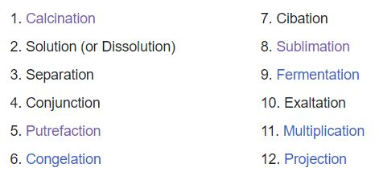  Well, maybe. Or it could be simple description.  33/ The ships languish helplessly like Bajazeth the Turkish Emperor captured by Tamburlaine (the shepherd) in Marlowe’s 1587 play who kills himself by smashing his own head against the bars of his cage after being used as a footstool by Tamburlaine.  No ‘Gentle Shepherd’ this one so we are a long way from the shepherd being Jesus. Donne is aged 25 and believes perhaps in miracles but not so much in a beneficent God.  35/  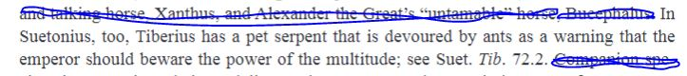  The emperor is Tiberius who had a pet snake and the ants are representative of the populace (probably why he chose to live on an island). Here all the despised and slow ships propelled by oars are suddenly much more effective than the fast sail ships which may as well now be bed-ridden for lack of any wind in their sails.  37/ reciting the names of these type of vessels, though, does show delight in his new-found nautical lingo  39/ He reviews the reasons he, and perhaps his companions on the ship, have for being on the expedition -  - broke and indebted  - to get out of a love affair that has perhaps become somewhat cloying,  - a career move  - or at least a fair death (better than torture and rotting in jail anyway - not an unreasonable wish in his family circumstances)  But here on a stricken ship they are all, quite literally, in the same boat. Cleverness means nothing and the reckless have exactly the same chance of surviving as the cautious  This must have been quite a change for someone who had been living on the edge for his entire life, marked as an Outsider for his birth religion and then as an Apostate so perhaps the camaraderie of the ship is not unwelcome. It is the helplessness of the ships he is railing against here and not his own.  45/ Cut off even from the hunter and prey dynamic of the natural world … they are so stupified (see ‘stupid’, line 2) that they can not die, kill or even pray.  It is like a grim version of the lotus eaters in The Odyssey.  There is nobody to pray to anyway, except maybe to Atrox Fortuna, the Roman goddess of Fate.  I wonder though if these would be Donne’s private thoughts or if the concentration on Roman imagery is from the University culture of reading the classics that he shared with Christopher Brooke and would take them both back to happier days. The Calm is of course the second part of the same work as The Storm which was certainly written for Brooke  I can’t help wondering also how much he had to do with Raleigh his commanding officer who was perhaps as close as anyone in that age was to being an Atheist. Certainly there would be an appeal in not having to pick a side, denominationwise, and this would have been written during the shortish spell of relatively free philosophical speculation before the later clampdowns.  49/ He seems to be saying here that prayer, anyway would be entirely futile and that the world is just how it is and that it will do what it will do  51/ this sounds like Hamlet’s soliloquy, written a couple of years later - between 1599 and 1602 - and also reflecting on what it is to be a human and wondering if it is possible for the individual to take any kind of control of his fate  For Donne and his crew mates, becalmed in the Azores, it is not possible. They have no agency or ability to influence events … all that is left is their awareness of their plight

Language and Poetic Techniques

The poem is largely in iambic pentameter but to my ear some lines are longer lines. To my ear, lines 5, 6, 10, 21, 36, 44, 47, 48, 50 and 52 are hexameters which is not a regular pattern but just a drawing out of the line when needed which slows it down. Quite appropriate for a poem about being stuck in time and space.

Sometimes the initial iamb is inverted into a trochee so the stress is on the first syllable which gives the line a kickstart… eg L8 - Smooth as thy mistress glass , L18- Feathers and dust, L35 - Languish our ships … L39, L43, L45, L47, 49, 50, 51, 53, 54 and 55 definitely … and arguably some others
This does give the poem an energy and forward propulsion which entirely stops it being depressing despite the appalling scenes and despondancy being described
Along with the lushness of the language.

The rhyme scheme is regular rhyming couplets, AA,BB ,CC etc but with internal rhymes .. or almost anagrams
Eg line6 … calms, laughs, languish. And along consecututve lines eg 22/23 … meteor, calenture
It is almost as if he is painting with language and it is coloured by the enjoyment of writing to a friend who he knows will delight in his letter, appreciate his verbal skill and be appropriately horrified by his dreadful experiences at sea. It is a poem of reportage and of philosophical speculation but also a poem of friendship
________________________________________

2/A Nocturnal upon St.Lucy's Day
Biographical context

The date this poem was written and therefore the biographical context is unclear
To some people it seems clear that it was written in 1627 when both his patron Lucy Countess of Bedford as well as Donne’s fifth child Lucy, then aged 18, to whom the countess had stood as godmother, died and the reason why this seems likely is obvious

Others think that it could only be about the death in 1617 of his wife, Ann, to whom he was genuinely devoted and by whose death he was devastated. It might also be thought that only Ann’s death could have caused the level of despair portrayed.
The poem also contains some of the imagery of ‘A Valediction Forbidding Mourning’, presumably written to Ann as he was heading off to Europe but since Donne does frequently recycle imagery, this hardly proves much.

I think it may have been earlier. If Rundell is right about “The Bracelet” being really about the death of his younger brother and constant companion, Henry, In 1593, when Donne was twenty-one, then maybe this one is too.
Henry was arrested for hiding a Jesuit priest in his rooms in London and died in jail of a fever. (The priest was hanged, drawn, and quartered.) Donne is not known to have visited him in prison and his grief and also feelings of unspeakable guilt about this and failing to keep his little brother from harm would certainly be strong enough to be the emotional engine of this poem. Although of course deeply disguised as it would need to be.

- 'Tis the year's midnight, and it is the day's,  - Lucy's, who scarce seven hours herself unmasks;  - The sun is spent, and now his flasks  - Send forth light squibs, no constant rays;  - The world's whole sap is sunk;  - The general balm th' hydroptic earth hath drunk,  - Whither, as to the bed's feet, life is shrunk,  - Dead and interr'd; yet all these seem to laugh,  - Compar'd with me, who am their epitaph.  - Study me then, you who shall lovers be  - At the next world, that is, at the next spring;  - For I am every dead thing,  - In whom Love wrought new alchemy.  - For his art did express  - A quintessence even from nothingness,  - From dull privations, and lean emptiness;  - He ruin'd me, and I am re-begot  - Of absence, darkness, death: things which are not.  - All others, from all things, draw all that's good,  - Life, soul, form, spirit, whence they being have;  - I, by Love's limbec, am the grave  - Of all that's nothing. Oft a flood  - Have we two wept, and so  - Drown'd the whole world, us two; oft did we grow  - To be two chaoses, when we did show  - Care to aught else; and often absences  - Withdrew our souls, and made us carcasses.  - But I am by her death (which word wrongs her)  - Of the first nothing the elixir grown;  - Were I a man, that I were one  - I needs must know; I should prefer,  - If I were any beast,  - Some ends, some means; yea plants, yea stones detest,  - And love; all, all some properties invest;  - If I an ordinary nothing were,  - As shadow, a light and body must be here.  - But I am none; nor will my sun renew.  - You lovers, for whose sake the lesser sun  - At this time to the Goat is run  - To fetch new lust, and give it you,  - Enjoy your summer all;  - Since she enjoys her long night's festival,  - Let me prepare towards her, and let me call  - This hour her vigil, and her eve, since this  - Both the year's, and the day's deep midnight is. | 1/ The time is St Lucys Day, the winter solstice in the Julian calendar, the shortest and darkest day of the year. St Lucy of Syracuse was said to wear a crown of candles around her head so she could see with both hands free as she brought food to the Christians hiding in the darkness of the catacombs. She was martyred and is the patron saint of the blind  The weak sun only shines for seven hours before exhausting itself and the only light the feeble flicker of stars  The earth itself is lifeless and dry, shrunk not just to the foot of the bed but its feet!  Even so it is more cheerful than the speaker who has no more life than words engraved on a stone; the words presumably describing the person for whom he is grieving  Then the poet addresses prospective lovers and this is where the poem divides into circular and linear time. Everyone is at their bleakest in midwinter but the lovers, like Nature itself will recover in the Spring.  The speaker, on the other hand, in whom ‘Love wrought new alchemy’ will be staying on the same trajectory ie/ from bad to worse  The alchemical process take the Prima Materia (whatever that is) and though a number (usually 12)  of processes it becomes the quintessence or higher and purer form of itself; perhaps gold, perhaps the Philosopher's Stone, the panacea which will cure everything or the Elixir which will give Eternal Life  The speaker’s ‘New Alchemy’, though, is going in the opposite direction and taking ‘dull privations’ etc as its prima materia, and through ‘Love's limbec’ (the 12 processes in the alembic of which the Dissolution and Separation are described here) becoming the Quintessence, the unimaginably intense and extreme, form of itself and heading directly into negative being  Animals have more life; plants ‘detest and love’, grow away from or towards the sun and stones can be magnetised but he himself has no properties at all. Even to cast a shadow he would need a light-source and to have solidity and but he has not even that. He is become the quintessence of Nothing. And there will be no renewal for him.  For the lovers under the ‘lesser sun’ ie/ the normal one will get through the time of Capricorn and, energised by lust, basically get on with their normal boring Lives  whereas our speaker is looking and moving towards his lost love as she “enjoys her long nights festival” which is perhaps something like the grisly Dance Macabre.  However, at the very end, the speaker out of his Nothingness does seem to summon up the agency to Name things and then we realise we are back at the very start of the poem, at midnight on St Lucy’s day  So perhaps Time, even for the poet, IS circular after all

Language and Poetic Techniques

There are five stanzas … five being the number of both the Virgin (see Gawain and the Green Knight) and of Venus (the orbit of the planet Venus traces the shape of a five petalled flower)

Each stanza has the longest lines of 5 feet at the beginning and at the end and the shortest line of 3 feet in the centre. This works on the ear as well as on the eye and represents both the Winter Solstice and the shape of an hour glass. So, both Saturn and the two kinds of Time since it could be Time draining away irrevocably or alternatively the hourglass can be turned upside-down to start a new phase.

The rhyme scheme is ABBACCCDD which Donne also uses for ‘The Indifferent’ , ‘A Valediction: of the Book’ and ‘The Canonization’. I think, but cannot be sure, that it is more or less unique to Donne; the three C rhymes always come as a surprise and a delight to the ear

I don’t know when this poem was written but its sheer extravagance of sentiment “I am Dead , I am deader than dead … go ahead and Enjoy Yourselves and Don’t Mind Me, I am the Deadest Thing Ever” seem definitely youthful to me
But of course we all carry the young person inside us even when we are old so my guess may be wrong on this one

How has my Understanding of Donne changed?

Well, considering it started at thinking he lived in an entirely different century, it has changed quite a lot and in a good way
But I am out of time and words or I would write more
Anita Greg 29/11/2023

