DIANA AND ACTAEON (1556-9)
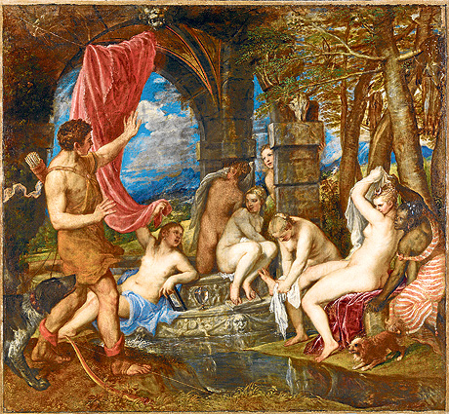
Diana and Actaeon explores the moment Actaeon accidentally happens upon the secret bathing place of Diana, chaste goddess of the hunt.

DIANA AND ACTAEON
by
TONY
HARRISON

And you, sir, yes, sir, you who just began
to read these lines you’re, maybe, a marked man.
Haven’t you half thought that while you view
Actaeon’s intrusion you’re intruding too?
Perhaps too chubby for most modern tastes
for less ample pulchritude and skinny waists,
Diana, scorned by connoisseurs of scrawn,
punishes those who’d pimp her as plump porn.
Actaeon stares at the stag skull, the flayed skin
above the nymph who dries Diana’s shin.
The stag skull in its dominant position
over mortal flesh immortalised by Titian,
maybe marks you out to share Actaeon’s doom
after you’ve left the safety of this room.
On those Diana’s flesh makes salivate
and clock the stag skull’s sockets far too late
stiff sprouting hairs will suddenly appear
and flesh-hooked faces fur up like doomed deer.
As you exit through the gallery’s glass doors
that antlered head reflected, is it yours?
For survival’s sake when leaving best beware
of baying bloodhounds in Trafalgar Square.

